**The Millennium Project**

**State of the Future Index**Study initiated and conducted by Theodore J. Gordon

Top of Form

Bottom of Form

The State of the Future Index is a measure of the 10-year outlook for the future. It is constructed with key variables and forecasts that, in the aggregate, depict whether the future promises to be better or worse. The SOFI is intended to show the directions and intensity of change in the outlook and to identify the factors responsible. Some of the Millennium Project’s experiments with the index have illustrated how it might be used for policy purposes by demonstrating the effects of proposed policies on a nominal State of the Future Index. The SOFI approach provides a mechanism for studying the relationships among the items in a system—how making a single change ripples throughout a system, in other words, creating some positive and intended consequence as well as unintended results and, with 2007’s work, standards for constructing national SOFIs that will enhance nation to nation comparisons.

Yet, combining many variables into a single index number can lead to loss of detail. Creating an index requires judgments not only in selecting the variables to include but also in weighting them. An index of global conditions can mask variations among regions, nations, or groups. The apparent precision of an index can easily be mistaken for accuracy. For these reasons, many people interested in tracking social or economic conditions prefer to keep the variables that they consider important separate and distinct. Hence, great attention is given to the variables that make up the index, seeking accurate sources and tracking changes when they occur.

The State of the Future Index was first described in the Millennium Project’s [2001 State of the Future](http://www.millennium-project.org/millennium/issues.html). Since then, the SOFI chapter in [*State of the Future*](http://www.millennium-project.org/millennium/issues.html) reports has focused on improvements in the data sources and the method itself. Details on all SOFI reserach and the analysis and supporting data are included in Chapter 2 on the CD that accompany the [*State of the Future*](http://www.millennium-project.org/millennium/issues.html) reports.

**Variables Included in the 2007 SOFI:**

* Population lacking access to improved water sources (percent of population)
* Literacy rate, adult total (percent of people aged 15 and above)
* Levels of corruption (15 largest countries)
* School enrollment, secondary (percent gross)
* Poverty headcount ratio at $1 a day (PPP) (percent of population) (Low and Middle Income Countries)
* Countries having or thought to have plans for nuclear weapons (number)
* CO2 emissions (global, kt)
* Unemployment, total (percent of total labor force)
* GDP per unit of energy use (constant 2000 PPP $ per kg of oil equivalent)
* Number of major armed conflicts (number of deaths >1,000)
* Population growth (annual percent)
* R&D expenditures (percent of national budget)
* People killed or injured in terrorist attacks (number)
* Energy produced from non fission, non fossil sources (percent of total primary energy supply)
* Food availability (cal/cap)
* Population in countries that are free (percent of total global population)
* Global Surface Temperature Anomalies
* GDP per capita (constant 2000 US$)
* People voting in Elections (percent population of voting age)
* Physicians (per 1,000 people)( surrogate for Healthcare Workers)
* Internet users (per 1,000 pop)
* Infant mortality (deaths per 1,000 births)
* Forest Lands (percent of all land area)
* Life expectancy at birth (years)
* Women in parliaments (percent of all members)
* Number of Refugees (per 100,000 total population)
* Total debt service (percent of GNI) (Low and Mid Income Countries)
* Prevalence of HIV (percent of population)
* Homicides, intentional (per 100,000 population)

SOFI 2007 with Trend Impact Analysis

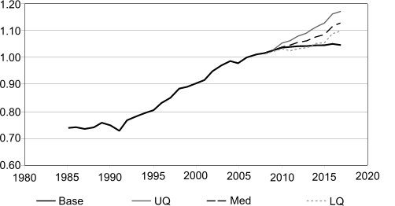

[**Read the SOFI study**](http://www.millennium-project.org/millennium/SOFI.pdf) (PDF file excerpt from [2007 State of the Future](http://www.millennium-project.org/millennium/sof2007.html)) for:  
- SOFI history, description, logic, and suggested uses  
- Annual Global SOFIs since 2001  
- National SOFIs for 10 American countries (2004 and 2005), Turkey and South Korea (2007)